本期内容
- DStream与RDD关系彻底研究
- Streaming中RDD的生产彻底研究
Spark中根本没有流处理一说，就是批处理
将详细讨论DStream模板下的RDD是如何被创建，然后被执行的。在开始叙述之前，先来思考几个问题，本篇文章是基于此问题构建的。
- RDD是谁产生的？
- 如何产生RDD?
带着这两个问题开启我们的探索之旅
- 实战WordCount源码如下:
object WordCount {
def main(args:Array[String]): Unit ={
val sparkConf = new SparkConf().setMaster("Master:7077").setAppName("WordCount")
val ssc = new StreamingContext(sparkConf,Seconds(1))

val lines = ssc.socketTextStream("Master",9999)
val words = lines.flatMap(_.split(" "))
val wordCounts = words.map(x => (x,1)).reduceByKey(_+_)
wordCounts.print()
ssc.start()
ssc.awaitTermination()
}
}
- DStream之间是有依赖关系，比如map操作，产生MappedDStream.
/** Return a new DStream by applying a function to all elements of this DStream. */def map[U: ClassTag](mapFunc: T => U): DStream[U] = ssc.withScope {
new MappedDStream(this, context.sparkContext.clean(mapFunc))
}
- MappedDStream中的compute方法，会先获取parent DStream，然后基于结果进行map操作，其中mapFunc就是我们传入的业务逻辑。
package org.apache.spark.streaming.dstream
import org.apache.spark.streaming.{Duration, Time}
import org.apache.spark.rdd.RDD
import scala.reflect.ClassTag
private[streaming]
class MappedDStream[T: ClassTag, U: ClassTag] (
parent: DStream[T],
mapFunc: T => U
) extends DStream[U](parent.ssc) {
override def dependencies: List[DStream[_]] = List(parent)
override def slideDuration: Duration = parent.slideDuration
override def compute(validTime: Time): Option[RDD[U]] = {
parent.getOrCompute(validTime).map(_.map[U](mapFunc))
}
}
- DStream
- 每个DStream之间有依赖关系，除了第一个DStream是基于数据源产生，其他DStream均依赖于前面的DStream
- DStream基于时间产生RDD.
/**
* A Discretized Stream (DStream), the basic abstraction in Spark Streaming, is a continuous
* sequence of RDDs (of the same type) representing a continuous stream of data (see
* org.apache.spark.rdd.RDD in the Spark core documentation for more details on RDDs).
* DStreams can either be created from live data (such as, data from TCP sockets, Kafka, Flume,
* etc.) using a [[org.apache.spark.streaming.StreamingContext]] or it can be generated by
* transforming existing DStreams using operations such as `map`,
* `window` and `reduceByKeyAndWindow`. While a Spark Streaming program is running, each DStream
* periodically generates a RDD, either from live data or by transforming the RDD generated by a
* parent DStream.
*
* This class contains the basic operations available on all DStreams, such as `map`, `filter` and
* `window`. In addition, [[org.apache.spark.streaming.dstream.PairDStreamFunctions]] contains
* operations available only on DStreams of key-value pairs, such as `groupByKeyAndWindow` and
* `join`. These operations are automatically available on any DStream of pairs
* (e.g., DStream[(Int, Int)] through implicit conversions.
*
* DStreams internally is characterized by a few basic properties:
* - A list of other DStreams that the DStream depends on
* - A time interval at which the DStream generates an RDD
* - A function that is used to generate an RDD after each time interval
*/
abstract class DStream[T: ClassTag] (
@transient private[streaming] var ssc: StreamingContext
) extends Serializable with Logging {
至此，我们就知道了，RDD是DStream产生的，那么DStream是如何产生RDD的了？
- DStream中的generatedRDDS的HashMap中每个Time都会产生一个RDD，而每个RDD都对应着一个Job，因为此时的RDD就是整个DStream操作的时间间隔的最后一个RDD，而最后一个RDD和前面的RDD是有依赖关系。
// RDDs generated, marked as private[streaming] so that testsuites can access it
@transient
private[streaming] var generatedRDDs = new HashMap[Time, RDD[T]] ()

generatedRDDS是DStream的成员，说明DStream的实例中均有此成员，但是实质在运行的时候指抓住最后一个DStream的句柄。
generatedRDDS在哪里被实例化的？搞清楚了这里的HashMap在哪里被实例化的话，就知道RDD是怎么产生的。
// RDDs generated, marked as private[streaming] so that testsuites can access it
@transient
private[streaming] var generatedRDDs = new HashMap[Time, RDD[T]] ()
1.DStream中的getOrCompute会根据时间生成RDD.
/**
* Get the RDD corresponding to the given time; either retrieve it from cache
* or compute-and-cache it.
*/
private[streaming] final def getOrCompute(time: Time): Option[RDD[T]] = {
// If RDD was already generated, then retrieve it from HashMap,
// or else compute the RDD
generatedRDDs.get(time).orElse {
// Compute the RDD if time is valid (e.g. correct time in a sliding window)
// of RDD generation, else generate nothing.
if (isTimeValid(time)) {
val rddOption = createRDDWithLocalProperties(time, displayInnerRDDOps = false) {
// Disable checks for existing output directories in jobs launched by the streaming
// scheduler, since we may need to write output to an existing directory during checkpoint
// recovery; see SPARK-4835 for more details. We need to have this call here because
// compute() might cause Spark jobs to be launched.
PairRDDFunctions.disableOutputSpecValidation.withValue(true) {
//根据时间计算产生的RDD
compute(time)
}
}
//rddOption里面有RDD生成的逻辑，然后生成的RDD,会put到generatedRDDS中
rddOption.foreach { case newRDD =>
// Register the generated RDD for caching and checkpointing
if (storageLevel != StorageLevel.NONE) {
newRDD.persist(storageLevel)
logDebug(s"Persisting RDD ${newRDD.id} for time $time to $storageLevel")
}
if (checkpointDuration != null && (time - zeroTime).isMultipleOf(checkpointDuration)) {
newRDD.checkpoint()
logInfo(s"Marking RDD ${newRDD.id} for time $time for checkpointing")
}
generatedRDDs.put(time, newRDD)
}
rddOption
} else {
None
}
}
}
- 在ReceiverInputDStream中compute源码如下：ReceiverInputDStream会生成计算链条中的首个RDD.后面的RDD就会依赖此RDD.
/**
* Generates RDDs with blocks received by the receiver of this stream. */
override def compute(validTime: Time): Option[RDD[T]] = {
val blockRDD = {
if (validTime < graph.startTime) {
// If this is called for any time before the start time of the context,
// then this returns an empty RDD. This may happen when recovering from a
// driver failure without any write ahead log to recover pre-failure data.
//如果没有输入数据会产生一系列空的RDD
new BlockRDD[T](ssc.sc, Array.empty)
} else {
// Otherwise, ask the tracker for all the blocks that have been allocated to this stream
// for this batch
//receiverTracker会跟踪数据
val receiverTracker = ssc.scheduler.receiverTracker
val blockInfos = receiverTracker.getBlocksOfBatch(validTime).getOrElse(id, Seq.empty)
// Register the input blocks information into InputInfoTracker
val inputInfo = StreamInputInfo(id, blockInfos.flatMap(_.numRecords).sum)
ssc.scheduler.inputInfoTracker.reportInfo(validTime, inputInfo)
// Create the BlockRDD
createBlockRDD(validTime, blockInfos)
}
}
Some(blockRDD)
}
- createBlockRDD源码如下:
private[streaming] def createBlockRDD(time: Time, blockInfos: Seq[ReceivedBlockInfo]): RDD[T] = {
if (blockInfos.nonEmpty) {
val blockIds = blockInfos.map { _.blockId.asInstanceOf[BlockId] }.toArray
// Are WAL record handles present with all the blocks
val areWALRecordHandlesPresent = blockInfos.forall { _.walRecordHandleOption.nonEmpty }
if (areWALRecordHandlesPresent) {
// If all the blocks have WAL record handle, then create a WALBackedBlockRDD
val isBlockIdValid = blockInfos.map { _.isBlockIdValid() }.toArray
val walRecordHandles = blockInfos.map { _.walRecordHandleOption.get }.toArray
new WriteAheadLogBackedBlockRDD[T](
ssc.sparkContext, blockIds, walRecordHandles, isBlockIdValid)
} else {
// Else, create a BlockRDD. However, if there are some blocks with WAL info but not
// others then that is unexpected and log a warning accordingly.
if (blockInfos.find(_.walRecordHandleOption.nonEmpty).nonEmpty) {
if (WriteAheadLogUtils.enableReceiverLog(ssc.conf)) {
logError("Some blocks do not have Write Ahead Log information; " +
"this is unexpected and data may not be recoverable after driver failures")
} else {
logWarning("Some blocks have Write Ahead Log information; this is unexpected")
}
}
//校验数据是否还存在，不存在就过滤掉，此时的master是BlockManager
val validBlockIds = blockIds.filter { id =>
ssc.sparkContext.env.blockManager.master.contains(id)
}
if (validBlockIds.size != blockIds.size) {
logWarning("Some blocks could not be recovered as they were not found in memory. " +
"To prevent such data loss, enabled Write Ahead Log (see programming guide " +
"for more details.")
}
new BlockRDD[T](ssc.sc, validBlockIds)
}
} else {
// If no block is ready now, creating WriteAheadLogBackedBlockRDD or BlockRDD
// according to the configuration
if (WriteAheadLogUtils.enableReceiverLog(ssc.conf)) {
new WriteAheadLogBackedBlockRDD[T](
ssc.sparkContext, Array.empty, Array.empty, Array.empty)
} else {
new BlockRDD[T](ssc.sc, Array.empty)
}
}
}
- map算子操作，产生MappedDStream
/** Return a new DStream by applying a function to all elements of this DStream. */def map[U: ClassTag](mapFunc: T => U): DStream[U] = ssc.withScope {
new MappedDStream(this, context.sparkContext.clean(mapFunc))
}
- MappedDStream源码如下，除了第一个DStream产生RDD之外，其他的DStream都是从前面的DStream产生的RDD开始计算，然后返回RDD,因此，对DStream的transformations操作就是对RDD进行transformations操作
private[streaming]class MappedDStream[T: ClassTag, U: ClassTag] (
parent: DStream[T],
mapFunc: T => U
) extends DStream[U](parent.ssc) {

override def dependencies: List[DStream[_]] = List(parent)

override def slideDuration: Duration = parent.slideDuration
//parent就是父DStream
override def compute(validTime: Time): Option[RDD[U]] = {
// getOrCompute是对RDD进行操作，后面的map就是对RDD进行操作
//DStream里面的计算其实是对RDD进行计算，而mapFunc就是我们要操作的具体业务逻辑。
parent.getOrCompute(validTime).map(_.map[U](mapFunc))
}
}
- forEachDStream的源码如下：
/**
* An internal DStream used to represent output operations like DStream.foreachRDD.
* @param parent Parent DStream
* @param foreachFunc Function to apply on each RDD generated by the parent DStream
* @param displayInnerRDDOps Whether the detailed callsites and scopes of the RDDs generated
* by `foreachFunc` will be displayed in the UI; only the scope and
* callsite of `DStream.foreachRDD` will be displayed.
*/
private[streaming]
class ForEachDStream[T: ClassTag] (
parent: DStream[T],
foreachFunc: (RDD[T], Time) => Unit,
displayInnerRDDOps: Boolean
) extends DStream[Unit](parent.ssc) {
override def dependencies: List[DStream[_]] = List(parent)
override def slideDuration: Duration = parent.slideDuration
override def compute(validTime: Time): Option[RDD[Unit]] = None
override def generateJob(time: Time): Option[Job] = {
parent.getOrCompute(time) match {
case Some(rdd) =>
//此时考虑jobFunc中一定有action操作
//因此jobFunc被调用的时候就会触发action操作
val jobFunc = () => createRDDWithLocalProperties(time, displayInnerRDDOps) {
foreachFunc(rdd, time)
}
Some(new Job(time, jobFunc))
case None => None
}
}
}

- 在上述案例中print函数源码如下，foreachFunc函数中直接对RDD进行操作
/**
* Print the first num elements of each RDD generated in this DStream. This is an output
* operator, so this DStream will be registered as an output stream and there materialized.
*/
def print(num: Int): Unit = ssc.withScope {
def foreachFunc: (RDD[T], Time) => Unit = {
(rdd: RDD[T], time: Time) => {
//action操作
val firstNum = rdd.take(num + 1)
// scalastyle:off println
println("-------------------------------------------")
println("Time: " + time)
println("-------------------------------------------")
firstNum.take(num).foreach(println)
if (firstNum.length > num) println("...")
println()
// scalastyle:on println
}
}
foreachRDD(context.sparkContext.clean(foreachFunc), displayInnerRDDOps = false)
}

上述都是从逻辑方面把RDD的生成流程走了一遍，下面我们就看正在开始是在哪里触发的。
- 在JobGenerator中generateJobs源码如下:
/** Generate jobs and perform checkpoint for the given `time`. */
private def generateJobs(time: Time) {
// Set the SparkEnv in this thread, so that job generation code can access the environment
// Example: BlockRDDs are created in this thread, and it needs to access BlockManager
// Update: This is probably redundant after threadlocal stuff in SparkEnv has been removed.
SparkEnv.set(ssc.env)
Try {
jobScheduler.receiverTracker.allocateBlocksToBatch(time) // allocate received blocks to batch
//生产Job
graph.generateJobs(time) // generate jobs using allocated block
} match {
case Success(jobs) =>
val streamIdToInputInfos = jobScheduler.inputInfoTracker.getInfo(time)
jobScheduler.submitJobSet(JobSet(time, jobs, streamIdToInputInfos))
case Failure(e) =>
jobScheduler.reportError("Error generating jobs for time " + time, e)
}
eventLoop.post(DoCheckpoint(time, clearCheckpointDataLater = false))
}
- 在DStreamGraph中我们前面分析的RDD的产生的动作正在被触发了
def generateJobs(time: Time): Seq[Job] = {
logDebug("Generating jobs for time " + time)
val jobs = this.synchronized {
//此时的outputStream就是forEachDStream
outputStreams.flatMap { outputStream =>
val jobOption = outputStream.generateJob(time)
jobOption.foreach(_.setCallSite(outputStream.creationSite))
jobOption
}
}
logDebug("Generated " + jobs.length + " jobs for time " + time)
jobs
}
rdd的action会不会产生rdd？
rdd的action不会产生rdd
foreachRDD既然产生了FroeachDStream，那么ForeachDStream就是一个DStream
如果里面的封装的那个函数没有action，那么就不会触发action的job的执行
ForeachDStream不一定触发job的执行，但是一定会job的产生，其实这句话是假的，但是job的真正产生是通过time产生的和框架产生的。
foreachRDD是spark Streaming的后门
在整个流处理中，直接对RDD产生操作，其实还是产生DStream，在整个流处理的过程中，我们看似操作的是RDD，但是实际还是操作DStream,DStream之间有依赖关系
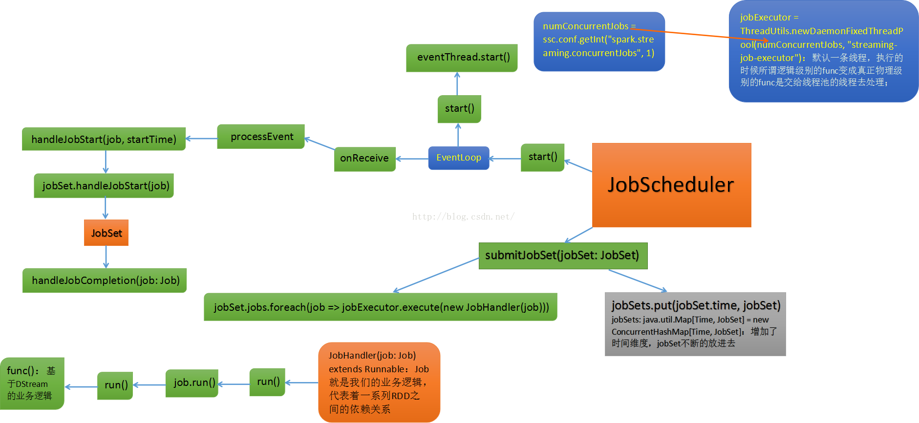

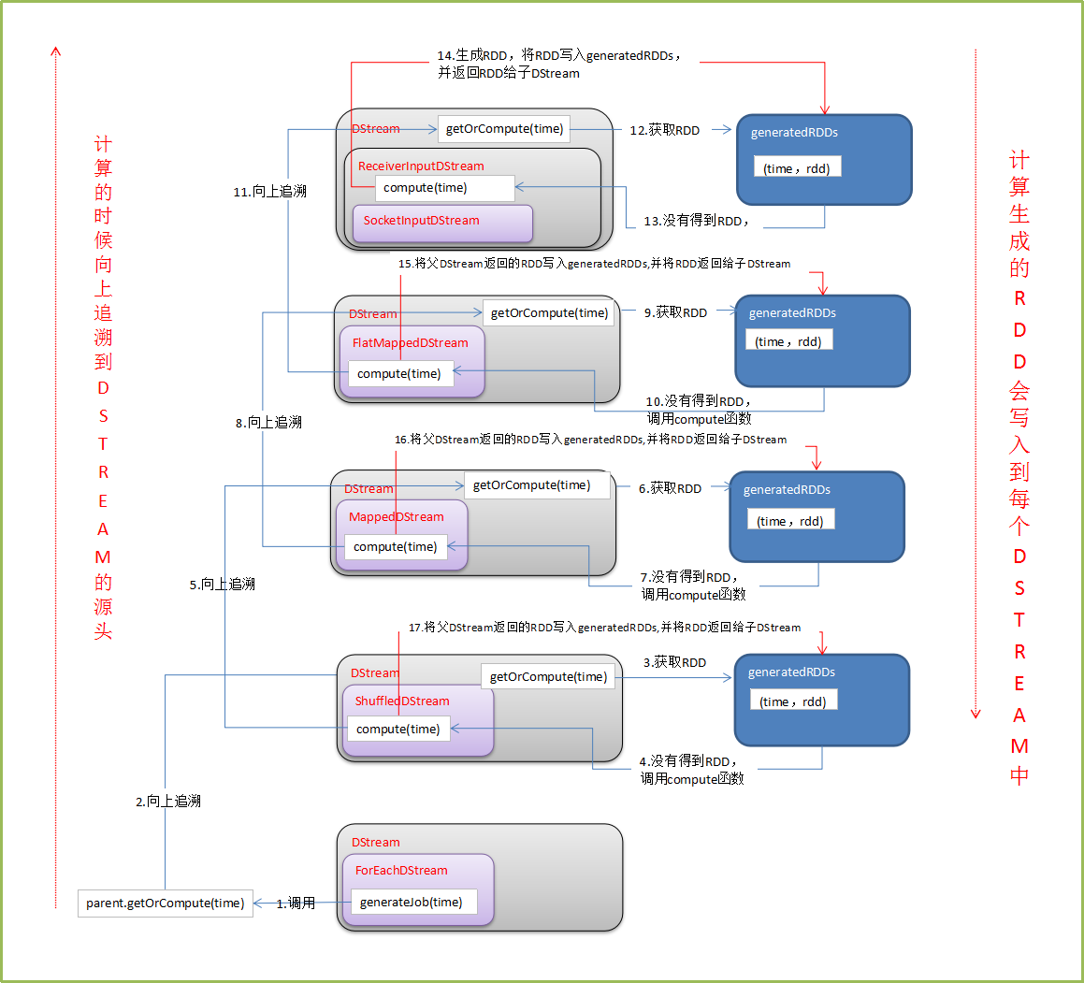
从而我们总结出这样一套说辞：
- DStream是RDD的模板，其内部generatedRDDS保存了每个BatchDuration时间生成的RDD对象实例。DStream的依赖构成了RDD依赖关系，即从后往前计算时，只要对最后一个DStream来计算即可。
- JobGenerator每隔BatchDuration调用DStreamGraph的generateJobs方法，调用了ForEachDStream的generateJob方法，其内部先调用父类

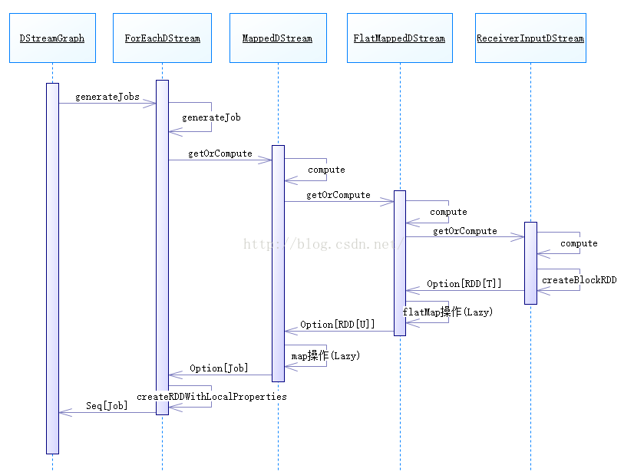
这里的print源码内部用foreachRDD将通过foreachFunc构建的(RDD,Time)扁你操作。
foreachRDD其实也是要产生ForEachDStream,对DStream遍历操作，ForEachDStream不会产生action操作，所以ForEachDStream操作是transforam级别的操作，所以我们得出一个结论；ForEachDStream并不是一定会触发Job的执行，但是会产生Job（不会触发执行）（真正的Job触发时Timer定时产生的额)
ForEachDStream会产生Job其实也是假象，因为没有ForEachDStream,也会产生Job，定时器Timer时间到了，管你有没有ForEachDStream,还是会产生Job并执行
DStream一共有三个关键重点:
- 除了第一个DStream,后面的DStream都要依赖前一个DStream
- DStream在每一个interval都会生成一个RDD
- 这个类里有个function可以对RDD进行操作
这里再次强调一下：DStream是RDD的模板，负责批量生成RDD
额外说明:为什么DStream要像RDD一样回溯，从后往前依赖，构建最后一个DStream?因为DStream要根据batch interval每隔一段时间产生RDD,必须和RDD高度步调一致（其实可以不一致，只不过会有很多问题).
这样又说明了：DStream是RDD模板，DStream Graph是DAG的模板
注意：Spark Streaming实际上没有所谓的实时流处理，实际上就是时间极端的情况下完成的批处理，就是我们之前所说的微批处理。
至此我们就完成了RDD生成的逻辑级别的解密

